SIMATS ENGINEERING
SAVEETHA INSTITUTE OF MEDICAL AND TECHNICAL SCIENCES
COMPUTER SCIENCE AND ENGINEERING PROGRAMME
CSA13 - THEORY OF COMPUTATION

NAME:Sangeetha J COURSE CODE:CSA1302
REG NO:192325050 COURSE NAME:THEORY OF COMPUTATION
1Write a C program to simulate a Deterministic Finite Automata (DFA) for the given language representing strings that start with a and end with a
AIM
To write a C program to simulate a Deterministic Finite Automaton (DFA) that accepts strings that start with a and end with a.
ALGORITHM
- Start the program.
- Read a string containing only a and b.
- Check whether the first character is a.
- Check whether the last character is a.
- If both conditions are satisfied, print Accepted; otherwise, print Rejected.
- Stop the program.
Code:
#include <stdio.h>
#include <string.h>
int main()
{
char str[100];
printf("Enter a string: ");
scanf("%s", str);

int len = strlen(str);

if (str[0] == 'a' && str[len - 1] == 'a')
printf("String Accepted");
else
printf("String Rejected");

return 0;
}

output
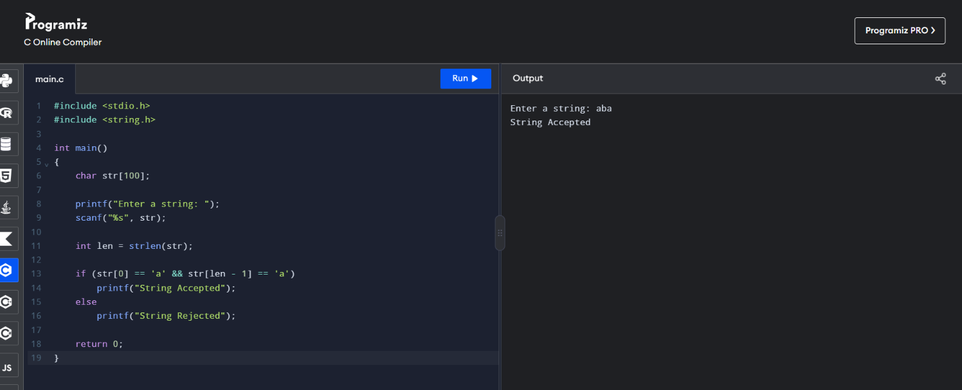

- Write a C program to simulate a Non-Deterministic Finite Automata (NFA) for the given language representing strings that start with o and end with 1
AIM
To write a C program to simulate a Non-Deterministic Finite Automaton (NFA) that accepts binary strings starting with 0 and ending with 1.
ALGORITHM
- Start the program.
- Read a binary string containing 0 and 1.
- Check whether the first character is 0.
- Check whether the last character is 1.
- If both conditions are satisfied and the string has at least two characters, print String Accepted; otherwise, print String Rejected.
- Stop the program.
Code:
#include <stdio.h>
#include <string.h>
int main()
{
char str[100];
int len;
printf("Enter a binary string: ");
scanf("%s", str);

len = strlen(str);

if (len >= 2 && str[0] == '0' && str[len - 1] == '1')
printf("String Accepted");
else
printf("String Rejected");

return 0;
}
Ouput:
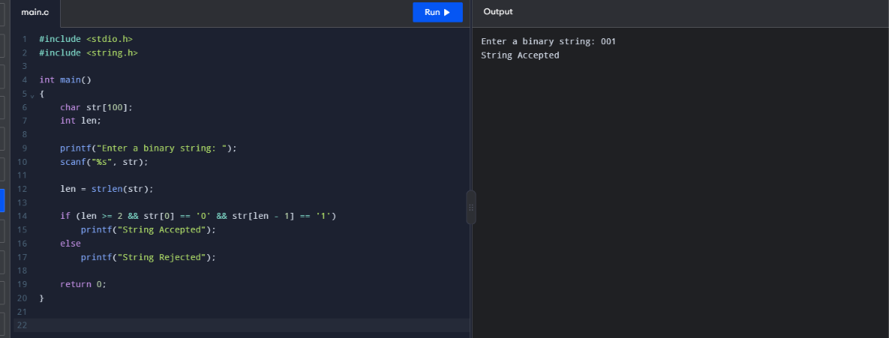

- Write a C program to find ε -closure for all the states in a Non-Deterministic Finite Automata (NFA) with ε -moves
AIM
To write a C program to find the ε-closure of all states in a Non-Deterministic Finite Automaton (NFA) with ε-moves.
ALGORITHM
- Start the program.
- Read the number of states and ε-transitions.
- Read the source and destination states of each ε-transition.
- For each state, find all states reachable through ε-transitions, including the state itself.
- Display the ε-closure of every state.
- Stop the program.
Code:
#include <stdio.h>
int main()
{
int n, m, i, j, k;
int a[10][10] = {0};
printf("Enter number of states: ");
scanf("%d", &n);

printf("Enter number of epsilon transitions: ");
scanf("%d", &m);

printf("Enter transitions (from to):\n");
for (i = 0; i < m; i++)
{
int x, y;
scanf("%d%d", &x, &y);
a[x][y] = 1;
}

for (k = 0; k < n; k++)
for (i = 0; i < n; i++)
for (j = 0; j < n; j++)
if (a[i][k] && a[k][j])
a[i][j] = 1;

for (i = 0; i < n; i++)
{
printf("Epsilon closure of q%d: {q%d", i, i);

for (j = 0; j < n; j++)
if (i != j && a[i][j])
printf(", q%d", j);

printf(" }\n");
}

return 0;
}

Output:
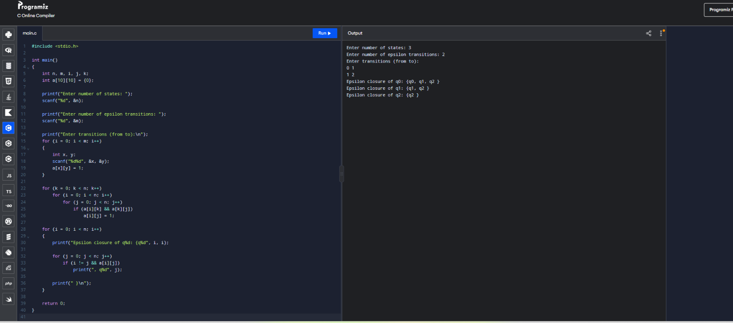

- To write a C program to check whether a string belongs to the grammar
S → 0 A 1
A → 0 A | 1 A | ε
AIM
To write a C program to check whether a string belongs to the grammar:
S → 0A1
A → 0A | 1A | ε
ALGORITHM
- Start the program.
- Read a binary string.
- Check whether the string starts with 0 and ends with 1.
- Check whether all characters in the string are either 0 or 1.
- If all conditions are satisfied and the string has at least two characters, print String Accepted; otherwise, print String Rejected.
- Stop the program.
CODE:
#include <stdio.h>
#include <string.h>
int main()
{
char str[100];
int i, len, valid = 1;
printf("Enter a string: ");
scanf("%s", str);

len = strlen(str);

if (len < 2 || str[0] != '0' || str[len - 1] != '1')
valid = 0;

for (i = 0; i < len; i++)
if (str[i] != '0' && str[i] != '1')
valid = 0;

if (valid)
printf("String Accepted");
else
printf("String Rejected");

return 0;
}
OUPUT:
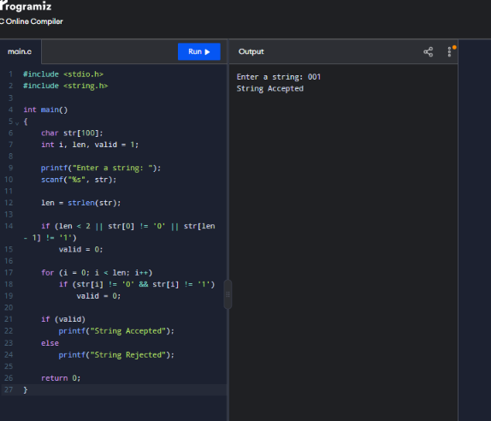

- To write a C program to check whether a string belongs to the grammar S -> 0 S 0 | 1 S 1 | 0 | 1 | ε
AIM
To write a C program to check whether a string belongs to the grammar:
- S → 0S0
- S → 1S1
- S → 0
- S → 1
- S → ε
ALGORITHM
- Start the program.
- Read a binary string.
- Compare characters from the beginning and end of the string.
- If the characters are equal, continue checking inward.
- If all matching pairs are equal, print String Accepted; otherwise, print String Rejected.
- Stop the program.
CODE:
#include <stdio.h>
#include <string.h>
int main()
{
char str[100];
int i, j, flag = 1;
printf("Enter a binary string: ");
scanf("%s", str);

i = 0;
j = strlen(str) - 1;

while (i < j)
{
if (str[i] != str[j])
{
flag = 0;
break;
}
i++;
j--;
}

if (flag)
printf("String Accepted");
else
printf("String Rejected");

return 0;
}
OUTPUT:
